**Project Name : Dream House**

**Project description :** Home selling website

**Users :**

1. Company
2. Buyer

**Roles :**

1. **Company :**
   1. Company has their own construction projects
   2. Ongoing construction projects
   3. Offering best sites to buyer
   4. Offers during festival
   5. Discount on big deals
   6. Company achievements
2. **Buyer :**
   1. Sign up/register using email id and password
   2. Login using login credentials
   3. Updating profile information (name, address, contact details, profession)
   4. Visit booking

**Inputs and Actions :**

**Sign up/Registration page :**

**Inputs :**

* Name
* Username
* Email ID
* Password
* OTP

**Actions :**

* Checking availability of username
* Email id verification-confirming email by OTP
* Register

**Login page :**

**Inputs :**

* Username
* Password

**Action :**

* Checking username & password
* Login

**Profile page :**

**Personal Information :**

* Name
* Address
* Email id
* Upload image
* Profession

**Property page :**

* Home type
* Address
* Price
* Photos
* Surrounding nature
* Contact details

**Offers availability :**

* Discount on big deals
* Festival offers

**Database design :**

* **Table_Registration :**
* Name
* User_ID
* Email
* Username
* Password
* Confirm_Password
* OTP
* **Table_User_Account :**
* Name
* User_ID
* Email_ID
* Address
* Profession
* Mobile_Number
* **Table_Visit_Book :**
* Name
* User_ID
* Address
* Profession
* Date
* Time
* **Table_property :**
* Property_Name
* Property_Details
* Property_Address
* Property_Price

**Wireframe design :**

**Home Page :**

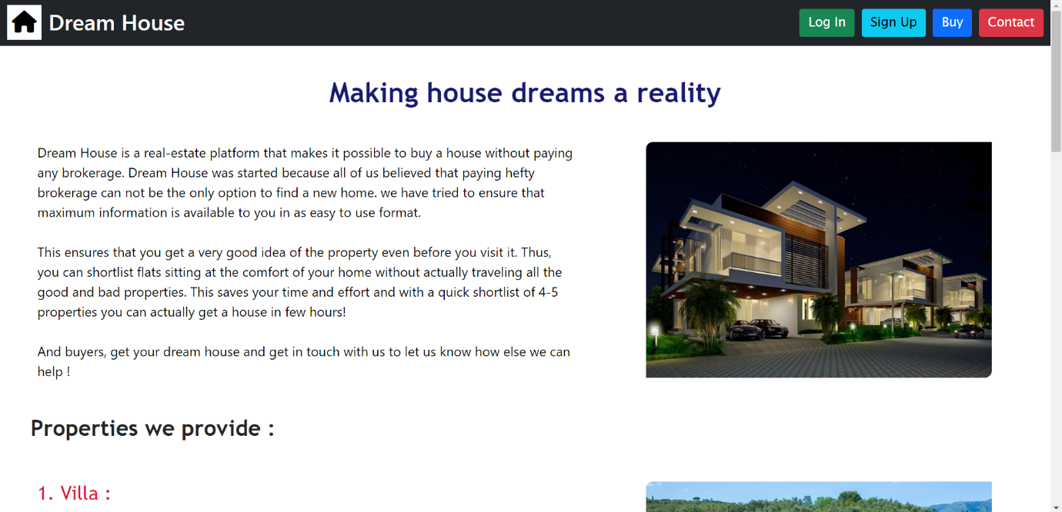

**Property Page :**

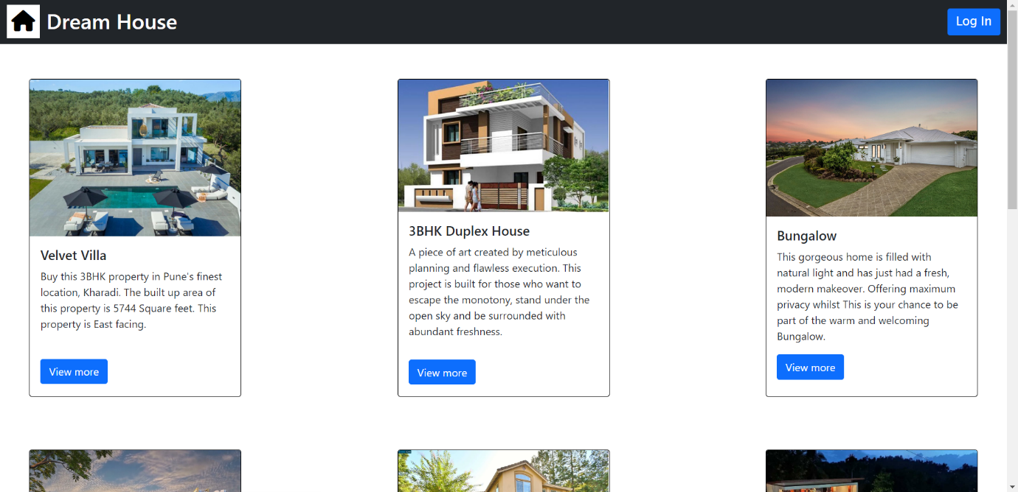

**Sign Up Page :**

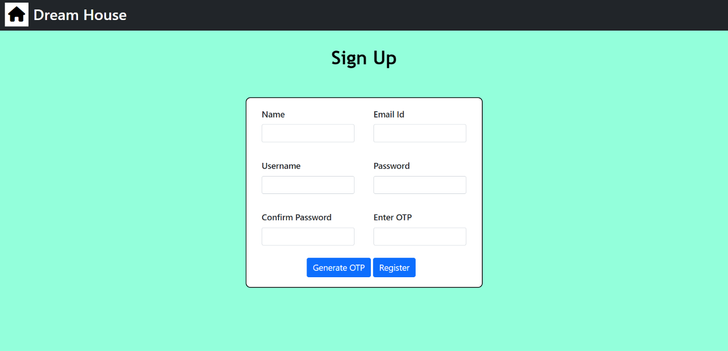

**Login Page :**

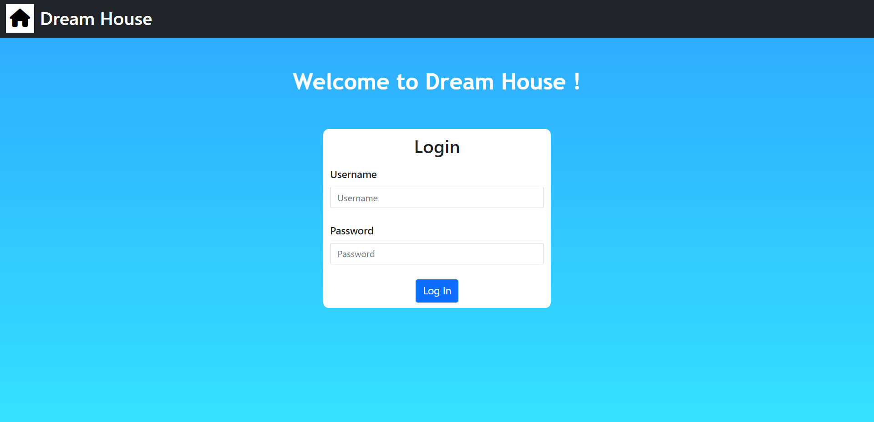

**User Profile :**

